Can Forest Management Reduce Fuels and Still Promote Biodiversity in Forests with a Mixed Severity Fire Regime?

Chris Adlam

6/2020

# Abstract

Mixed conifer-hardwood forests found along the Oregon and California coasts historically supported a fire regime of frequent, low to moderate-severity burning. Since Anglo-American settlement, the near-eradication of Indigenous burning practices and enforcement of fire suppression has nearly erased fire as an ecological force in these mixed evergreen forests. Today, the Karuk Tribe, US Forest Service, and local community organizations have formed the Western Klamath Restoration Partnership (WKRP) to restore this fire regime, which is fundamental to ecological composition, structure and function as well as ecosystem services that fulfill human needs. The WKRP seeks to reduce fuel loads around communities while addressing concerns about the impacts to biodiversity of high-severity fire on one hand, and of the exclusion of fire on the other. I investigated how communities of plants, birds, lichens and insects differ between long-unburnt stands, low-severity burns and high-severity burns. Then I evaluated the response of diversity to two management options used to mitigate the risk of high-severity fire by reducing fuels and canopy cover: wildland fire managed for resource benefit (the “passive” option) and forest thinning and prescribed burning (the “active” option). Based on 110 plots across the WKRP project area, low-severity burns and unburnt areas did not differ significantly in species composition. In addition, in high-severity burns, plant, bird and insect diversity (alpha, beta and gamma) were as high or higher than in low-severity/unburnt stands. Lichens were negatively impacted by high-severity fire, beginning to recover only after 16 years. Areas burned by multiple wildland fires and thinned/burnt stands had the highest diversity, because they provided habitat for both species preferring high-severity burns and those preferring low-severity/unburnt stands. My results suggest that management, whether passive (allowing fires to burn and overlap) or active (thinning and burning) can help maintain biodiversity in this fire-dependent landscape.

## Summary

* I recorded all species found in high-severity burns (most trees killed, more than 75% of the canopy), low-severity burns (a few trees killed, less than 25% of the canopy), and long-unburnt areas (no fires in the last 80 years).
* I found that the number of plant and bird species found in each plot in high-severity burns is as high or higher compared with low-severity burns and unburnt plots. There was also more difference between the plots in the high-severity burns, whereas the low-severity and unburnt plots tended to be more similar. Lastly, I found more species in total in the high-severity burns than in the low-severity and unburnt areas. These results show that forests that haven’t had fire in a long time are less diverse; a lot of species use high-severity burns but can’t live in dense, fire-suppressed forests. A single low-severity burn doesn’t make a noticeable difference, probably because it doesn’t change the canopy cover enough.
* Several kinds of insects also prefer high-severity burns, but fire-sensitive lichens aren’t found after a high-severity burn and only start to grow again after 16 years.
* I also surveyed stands that had burnt several times and thinned and burnt stands that had 30-70% canopy cover left. Diversity in these stands was the highest, significantly higher than either high-severity burns or low-severity and unburnt stands. These stands are more diverse because both species typical of open areas and high-severity burns and those typical of dense, fire-suppressed stands can be found living in them.
* These results suggest that management solutions proposed by the Karuk Tribe and WKRP, including letting more fires burn in the backcountry (when appropriate), and actively thinning and burning are beneficial to biodiversity as well as reducing fuel levels. Management may need to reduce canopy cover significantly (to 30-60%) where appropriate if conserving and restoring understory species is important.

# Introduction

In Western North American forests adapted to frequent fires predominantly of low to moderate-severity, concerns are mounting over the effect of changing fire regimes on biodiversity (Haugo et al., 2019; Hessburg et al., 2005; Steel et al., 2015). The historic fire regime of these forests, described as “mixed severity” (Halofsky et al., 2011; Hessburg et al., 2016; Perry et al., 2011), has beenaltered by a century of fire suppression and climate change in two contrasting ways: an extreme lack of fire on most of the landscape on one hand, and the increasing extent of high-severity fire on the other. The former threatens early seral habitats and open forests (Knapp et al., 2013; Odion et al., 2014; Swanson et al., 2014), while the latter threatens species and ecosystem services associated with mature forests (Miller et al., 2018; Miller and Safford, 2019). Despite a broad consensus that the exclusion of fire has been detrimental to biodiversity, disagreement remains over how to balance the ecological need to allow more fire in fire-dependent ecosystems and the need to mitigate the risk of high-severity fires to old growth-associated species, communities, and ecosystem services.

Managers seeking to move away from systematic fire suppression may turn to two approaches to achieve this balance. The active approach is to thin and burn stands to enhance populations of species negatively impacted by fire exclusion and minimize the likelihood of high-severity fires in places where there is a concern over the vulnerability of resources and rural communities (Abella and Springer, 2015; Kalies and Yocom Kent, 2016; Wayman and North, 2007; Webster and Halpern, 2010). However, thinning and burning has been criticized on the grounds that reducing the extent of high-severity fire could reduce the availability of ecologically important early seral habitats, while at the same time disturbing mature forest habitats and threatening associated species (Baker, 2015; Odion et al., 2014). The second approach is to let unplanned fires burn under appropriate weather and fuels conditions; this passive approach would lead to more frequent fires at larger scales, thus reducing fuel loading and canopy homogeneity across more of the landscape (North et al., 2012). Understanding the impacts of both active and passive forms of management is important to build a consensus over how to meet both fire management and biodiversity targets.

Such consensus is particularly needed in the context of collaborative landscape management agreements that are becoming increasingly common, particularly on national forests. In the Klamath Mountains of northern California, the Karuk Tribe, United States Forest Service and community and environmental organizations have formed the Western Klamath Restoration Partnership (WKRP) in order to restore the forest and steer the fire regime back towards the pattern of frequent, patchy, low to moderate-severity fires that prevailed prior to the disruption of Indigenous fire management and the widespread suppression of lighning-ignited fires (Crawford et al., 2015; Fry and Stephens, 2006; Taylor et al., 2016). Extensive planning discussions have taken place to identify zones of agreement among all partners, such as limiting damage to communities from high-severity fires and enhancing biodiversity (including both late seral species and fire-dependent, early seral species) (Harling and Tripp, 2014; Lake et al., 2018). But can management concurrently achieve both of these objectives, or will they necessarily be at odds?

Studies from related forest types such as inland dry forests suggest that treatments that reduce canopy cover can promote biodiversity (Bartuszevige and Kennedy, 2009), but such results are inconsistent (Willms et al., 2017) and their applicability to mixed severity forests is questionable (Hessburg et al., 2016). In this study, I surveyed biodiversity (birds, plants, lichens and insects) in long-unburnt stands and low-severity and high-severity single burns. I identified species associated with high-severity burns and long unburnt stands as early- and late-seral species respectively. I also surveyed thinned and burnt stands and multiple burns with intermediate canopy cover representative of forest restoration goals aimed at minimizing the risk of high-severity burns. To determine whether this type of management is also compatible with biodiversity conservation objectives, I then ask: do areas with intermediate canopies (actively or passively managed) provide habitat for early seral species, late seral species, both, or neither?

# Methods

## Study area

Located in the Klamath-Siskiyou mountains of northern California, the WKRP is a 1.2 million-acre collaborative landscape restoration effort between the Karuk Tribe, US Forest Service and local NGOs (Harling and Tripp, 2014) (Figure 1). The area is dominated by mixed evergreen forest (Steel et al., 2015), which is characterized by the prevalence of Douglas-fir (*Pseudotsuga menziesii*) and diverse hardwoods such as tanoak (*Notholithocarpus densiflorus*), black oak (*Quercus kelloggii*), canyon live oak (*Quercus chrysolepis*), and madrone (*Arbutus menziesii*) (Barbour and Billings, 2000; Whittaker, 1961). The landscape of the study area was historically managed by the Karuk tribe using frequent (~12.5 year interval), low-intensity prescribed burning (Crawford et al., 2015; Taylor and Skinner, 2003, 1998); lakeHistoricalCulturalFires2013]. As a result, the historic fire regime was one of more frequent and generally lower severity fires than would have been expected under the influence of climate alone (Carloni, 2005; Skinner et al., 2009; Taylor and Skinner, 1998; Taylor et al., 2016). One of the main goals of the WKRP is to restore the fire regimes within the Karuk tribe’s aboriginal territory in a way that promotes the resilience of these ecosystems to high-severity fire and climate change, and increases biodiversity and the provision of diverse ecosystem services (Harling and Tripp, 2014).

## Data collection

I conducted surveys at 110 sites varying in time-since-fire and burn severity (48 sites surveyed in 2018 and 62 in 2019). Sampling sites were in lower elevation (mean 759m, range 241-1500m) mixed evergreen forest, with some in transition areas into dry or moist mixed conifer (classification based on presettlement fire regime (Van de Water and Safford, 2011), accessed through the FRID dataset (Safford et al., 2011)). The median historic fire return interval in these forests is 13 years (Van de Water and Safford, 2011), with some variation based on aspect and other topographic and climatlic factors (Skinner et al., 2006; Taylor and Skinner, 1998).

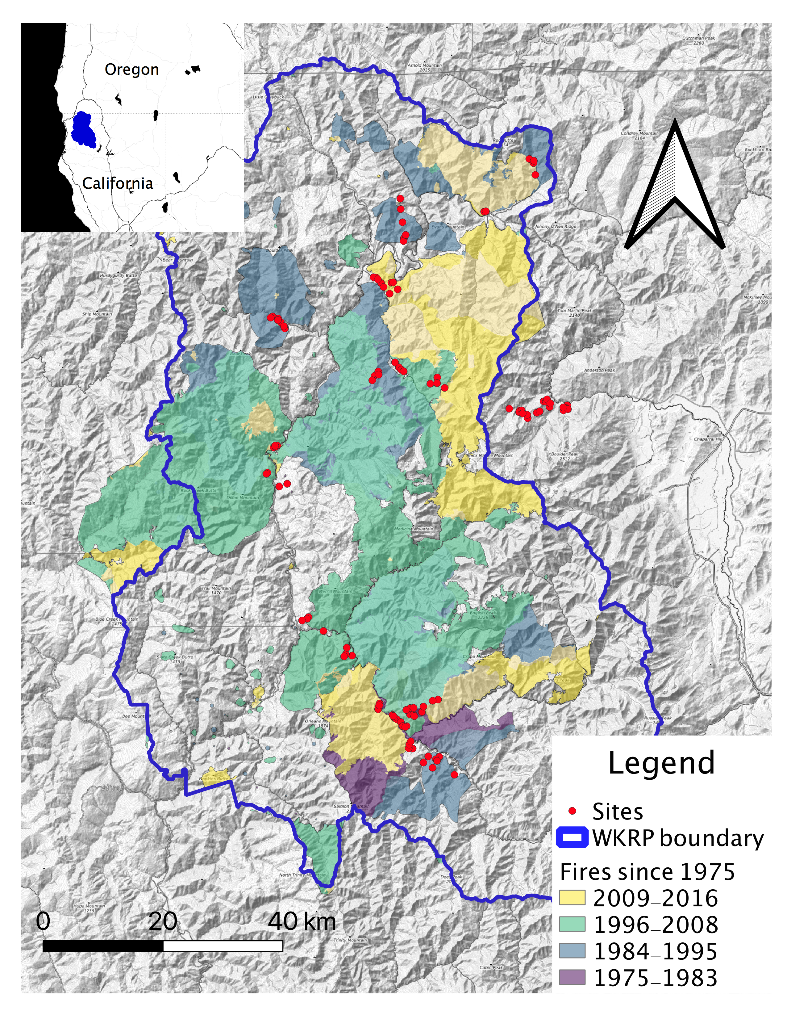

Map of WKRP project area and sampling sites

Sampling sites were placed in low-severity (“LS”) and high-severity burns (“HS”), defined respectively as <25% canopy mortality and >75% canopy mortality (J. D. Miller et al., 2009), in long-unburnt stands (“UN”, >80 years since last fire), in sites affected by multiple burns (“MULT”), and sites that were thinned and burnt (“Rx”). At all burnt sites, time-since-fire varied from 2 to 32 years. Multiple burns and thinned and burnt sites were placed in areas with intermediate canopy cover (30-75% cover). While this eliminates high-severity reburns and multiple burns or restoration treatments that retain high levels of canopy cover, this study only considered “treatments” (active or passive) that reduce canopy cover significantly. Such canopy reduction corresponds to the level recommended for understory restoration (Abella and Springer, 2015) and for mitigating the risk of crown fires (Moghaddas et al., 2010). As a result of this approach, the habitats studied follow a gradient of canopy cover (Figure 2). Burn severity was evaluated a priori based on the relative difference normalized burn ratio (Jay D. Miller et al., 2009; Miller and Thode, 2007) and verified in situ by visually estimating the magnitude of canopy cover reduction. Since the habitats differ mostly by the severity of fire’s impact, I will henceforth refer to different “severity categories” for simplicity, even though this is an imperfect description of multiple burn and thinned and burnt sites.

Several tests were used to ensure that the differences observed between severity categories were not simply the product of a climatic or topographic pattern. To test for climate differences, I compared the climatic water deficit (the difference between potential and actual evapotranspiration). Using the Basin Characterization Model 30-year average for 1981-2010 (Flint et al., 2013), I found no difference between the severity categories (ANOVA, *F*(4,105) = 1.41, *p* = 0.237). Then, I used measurements of slope, aspect and latitude to calculate the heat load at each site. Heat load indicates the magnitude of insolation and temperature and is equivalent to solar radiation but for two differences: it is symmetrical along the northeast-southwest axis rather than the north-south axis (since a slope with afternoon sun will have higher maximal temperatures than a similar slope with morning sun), and it can be calculated using a simple equation instead of requiring simulation modeling or manual interpolation using solar radiation tables (McCune and Keon, 2002). I found no detectable difference among categories except that heat load was slightly lower for high-severity sites (although this might seem counterintuitive, it is explained by the fact that high-severity sites were steeper on average, and heat load decreases with slope gradient on north-facing aspects). However, due to the limited availability of thinned and burnt areas, I had to make some concessions in study design. While there were numerous sites available for the other severity categories, the only prescribed burn sites that met this study’s criteria for minimum size, degree of canopy reduction, and absence of other disturbance factors were located in two project areas. These were higher in elevation on average than the other severity categories (mean = 1101m, 95% CL = 965-1237m) and more clustered (average distance among sites <10km compared to 28-36km for the other severity categories). Spatial autocorrelation of fire effects among plots within a burn unit is uncommon (**???**), but ecological communities could be expected to be more similar as a result of these sampling limitations. While these factors limit the generalizability of the patterns observed at these sites, this is a common challenge for studies of prescribed fires. Therefore I still include the thin+burn sites in the study in the hope that my findings can be used in designing more robust future investigations.

At each site, I recorded aspect, slope, elevation, and canopy cover (trees over 5m in height, by visual estimation). For all sites, I surveyed plants, epiphytic lichens, and birds. Presence of all plants and lichen species was determined in an 11.3m-radius plot (400 m2), a size commonly used for Common Stand Exams (USFS, 2008). Plants were identified using the Jepson manual (Baldwin et al., 2012) and lichens were identified using Mccune and Geiser’s Macrolichens of the Pacific Northwest (McCune and Geiser, 2009). Only native plant species are included in the analysis, although exotic species were generally few. Species of some plant genera were pooled if they shared similar ecological requirements (eg. *Arctostaphylos*, *Cryptantha*, *Pyrola*). Species of the lichen genera *Usnea* and *Bryoria* were also pooled because of the difficulty in differentiating them. I also conducted two 10-minute bird point counts at each site using standard methods (Ralph et al., 1993). These surveys took place on separate, non-consecutive days with no precipitation and little to no wind, between sunrise and 10:00am during breeding season (June-early July). All bird visual and aural detections within a 100m radius were recorded. The two hummingbird species (Anna’s and Rufous Hummingbird) were pooled, as were Black-throated Gray Warblers and Hermit Warblers (*Setophaga* sp.), because it was not always possible to differentiate these species by ear. Lastly, for high-severity, low-severity and unburnt sites, I set up a custom-built flight-intercept trap for flying insects that was left out for two days (Russo et al., 2011). Insects were identified to the order or suborder level.

## Analysis

### Species composition

I conducted a non-parametric multivariate permutational analysis of variance (PERMANOVA) to test the significance of dissimilarity between the different severity categories (McArdle and Anderson, 2001) using the adonis2() function from the vegan package v.2.5.6 in R (Oksanen et al., 2007), with 999 permutations. PERMANOVA calculates a pseudo-F value similar to the F-statistic in ANOVA models, and obtains p-values based on permutation procedures (Anderson, 2017). Then I conducted PERMANOVA pairwise comparisons between each severity category. To minimize the risk of making a type-1 error from carrying out multiple pairwise tests on a single data set, I adjusted the p-values using the Bonferroni correction method (Rice, 1989).

To visualize the difference in species composition in each severity category, I used non-metric multidimensional scaling (NMDS) based on Bray-Curtis dissimilarity matrices using the metaMDS() function of the vegan package in R (Oksanen et al., 2007).

### Diversity patterns

Next, I analyzed patterns of alpha, beta and gamma diversity for plants, birds, and lichens. Alpha diversity is equivalent to species richness per plot. Because assumptions of normality were often unmet with my data, I performed permutational ANOVAs using the aovp() function of the lmPerm package (Wheeler and Torchiano, 2016). Tukey HSD post-hoc tests were used to evaluate the significance of the difference in richness between severity categories.

To further evaluate the influence of canopy cover on species richness, I used linear regressions with plant and bird richness as the response variable and percent tree cover as the predictor for the lower canopy cover habitat (high-severity burns), intermediate canopy habitats (multiple and thinned and burnt stands), and higher canopy cover habitats (low-severity and unburnt). Data were square root transformed to acheive normality (verified using Shapiro-Wilkes tests). This tiered approach was chosen to isolate the effect of treatment and of canopy cover, since the treatments themselves are the principal driver of canopy cover differences.

I calculated beta diversity, or the amount of variation in species composition and richness between sites within each severity category, using the R package vegetarian v1.2 (Charney and Record, 2009). I used the 1-Jaccard index (Jost, 2007) to represent the extent to which species are shared in each pair of samples. I compared results between treatments using standard errors from bootstrapping given by the package vegetarian.

Because the number of samples in each severity category was unequal, simply comparing the total number of species found in each severity category was not an adequate way to evaluate gamma diversity, the size of the species pool for each habitat. Instead, I generated sample-based rarefaction curves (Colwell et al., 2012) using package iNEXT v. 2.0.20 (Chao et al., 2014; Hsieh et al., 2016). This method uses Hill numbers, or effective species numbers based on species richness. Estimates were interpolated from site-based incidence data to account for unequal sample sizes (Colwell et al., 2012) and then extrapolated to twice the size of the smallest sample (Chao et al., 2014). I compared results between treatments using 95% confidence intervals from bootstrapping.

### Indicator species analysis

Insects were not sampled in the multiple burns and thinned and burnt sites, but I include them nevertheless to compare species communities in the unburnt, low-severity and high-severity burns. Comparisons of alpha, beta and gamma diversity were not as meaningful for insects, because of the small number of taxa (at the order or suborder level). Instead, I used an indicator species analysis using the function multipatt() in the package indicspecies v1.7.8 (De Cáceres and Legendre, 2009) to determine which taxa showed a preference for high-severity or low-severity and unburnt stands (the latter were pooled because the PERMANOVA suggested their community composition did not differ). I used the same procedure to identify indicator species for birds and plants in the high-severity and low-severity/unburnt categories.

### Early and late seral species in actively and passively managed stands

Lastly, I wanted to determine if the multiple burns and thinned and burnt stands tended to contain species associated with high-severity burns and/or those associated with low-severity and unburnt stands. Four hypotheses were envisioned: 1) Species preferring high-severity burns also occur frequently in the actively or passively managed stands; 2) Species preferring unburnt stands and low-severity burns also occur frequently in the actively or passively managed stands; 3) Both of these species cohorts occur frequently in the actively or passively managed stands (presumably because they are intermediate in environmental characteristics such as canopy cover); 4) Neither cohort is found in the actively or passively managed stands (presumably because the intermediate conditions are inhospitable for both and instead favor a completely different species assemblage). In the first two cases, active or passive management would generate habitat conditions that are ecologically redundant with high-severity burns or denser mature stands. The third hypothesis would mean that reducing canopy cover for fire management would be most compatible with biodiversity objectives, while the fourth would be the worst case scenario. To determine which of these four hypotheses was correct, I identified species that prefer high-severity burns and species that prefer unburnt stands and low-severity burns by using a simple criterion: if a species was found at least twice as frequently in one habitat than the other, I considered that it exhibited a preference for that habitat. Only species that occurred in more than five sites (18% of the total number of sites) were included. I compared the list of early seral species (found twice as frequently in the high-severity burns) and late seral species (found twice as frequently in the low-severity burns and unburnt stands) with findings from geographically-related studies to ensure that my determination was accurate. For both groups of species, I then determined if each species was also found at least twice as frequently in the multiple burns and/or thinned and burnt stands. To determine which of the four hypotheses above was supported by the data, I evaluated the frequency with which species preferring high-severity burns or low-severity burns and unburnt stands also favored the multiple burns and/or thinned and burnt stands. In addition, for these species, Karuk cultural uses from the published literature were included to illustrate the interconnectedness of biological and cultural diversity (Long et al., 2020; Schenck and Gifford, 1952).

# Results

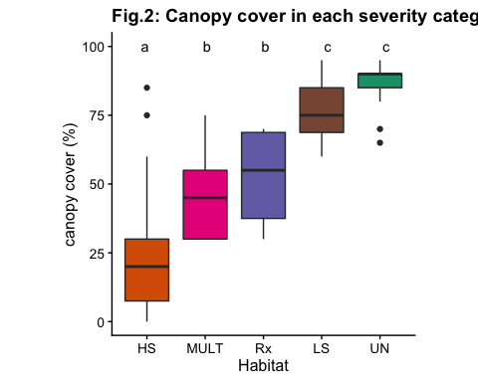

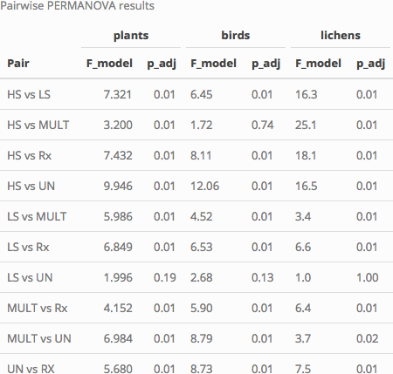

## Variation in community composition across habitats

### Effect of fire history on species composition

The main PERMANOVA revealed that species composition varies for all taxa in response to the severity category (*p* < 0.001). Using pairwise PERMANOVAs to compare the habitats, there is no detectable difference between plant and lichen communities of low-severity and unburnt stands, while the difference in bird communities was only marginally significant (Table 1). In addition, bird communities of high-severity burns and multiple burns are not detectably different. For lichens, contrary to expectations, the communities of multiple burns, thin+burn and low severity differed significantly.

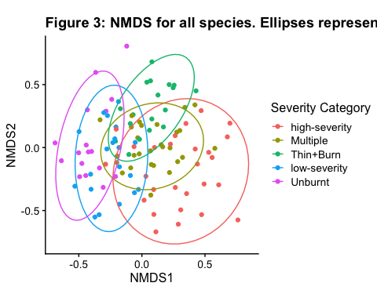

### Species assemblage ordination

The NMDS confirms a considerable overlap in species communities of long-unburnt and low-severity burn stands. high-severity stands have distinct species communities, while the communities in thinned and burnt stands and multiple burn stands appear to be intermediate between the high-severity stands and long-unburnt/low-severity stands. Figure 3 shows the first two dimensions of a 3-dimensional ordination that found convergent solutions with a stress of 0.176 (“stress” represents the degree of distortion required to reduce the dimensionality of the data; a stress of <0.20 is considered acceptable).

## Alpha, Beta, Gamma diversity patterns

### Alpha diversity

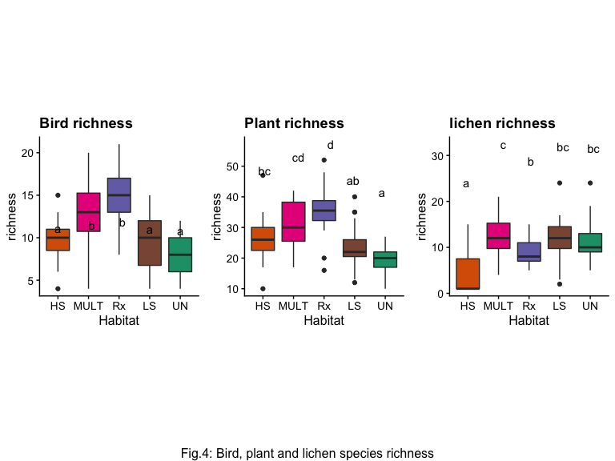

Bird and plant species richness were highest in the multiple burns and thinned and burnt stands (for plants the difference between high-severity burns and multiple burns was not significant) (Figure 4). Bird and plant richness in low-severity burns and unburnt plots was slightly lower than in high-severity burns, but the difference was overall not significant. Lichens were predictably less diverse in the high-severity stands, but richness in the other severity categories was similar.

Within the multiple burns and thinned and burnt stands, canopy cover was negatively correlated with plant richness (*F*(1,44) = 8.561, *p* = 0.005) and bird richness (*F*(1,44) = 5.302, *p* = 0.026). In the low-severity and long-unburnt stands, canopy cover was negatively correlated with bird richness (*F*(1,35) = 10.191, *p* = 0.003), but only weakly correlated with plant richness (*F*(1,35) = 2.254, *p* = 0.142). In the high-severity stands, canopy cover was not correlated with either plant or bird richness (*F*(1,25) = 2.382, *p* = 0.135 and *F*(1,25) = 1.863, *p* = 0.184 respectively).

### Beta Diversity

Beta diversity was highest in the high-severity burns and multiple burns for birds and plants, and lowest for the thinned and burnt stands, possibly because they were spatially clustered rather than because of an effect of treatment (figure 5). For lichens, high-severity burns had the highest beta diversity, likely not because of a high level of species turnover between sites, but rather because of the variation in species richness between plots with no surviving trees and those that had surviving trees, and therefore lichens.

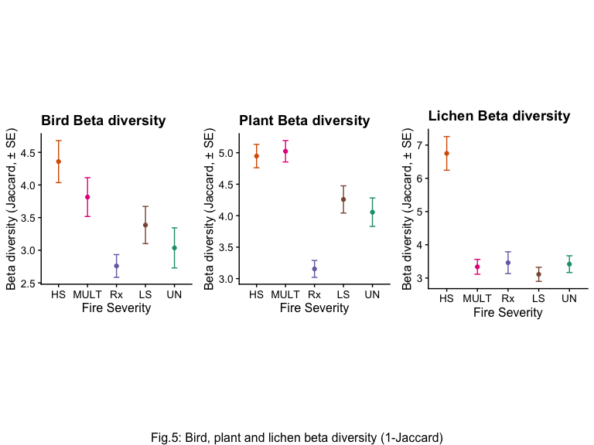

### Gamma diversity

Based on the extrapolated species richness, the total pool of species for birds appears to be largest in the multiple burns and thinned and burnt stands, intermediate in the high-severity burns, and lowest in the low-severity and long-unburnt stands (Fig. 5). For plants, the pattern is the same except that species pool from the thinned and burnt stands appears smaller than the high-severity burns, and more similar to the low-severity stands instead. high-severity fire eliminates lichens and most of their substrate (Miller et al., 2018), and their species pool is smaller in the high-severity stands than in the other severity categories, which are similar.

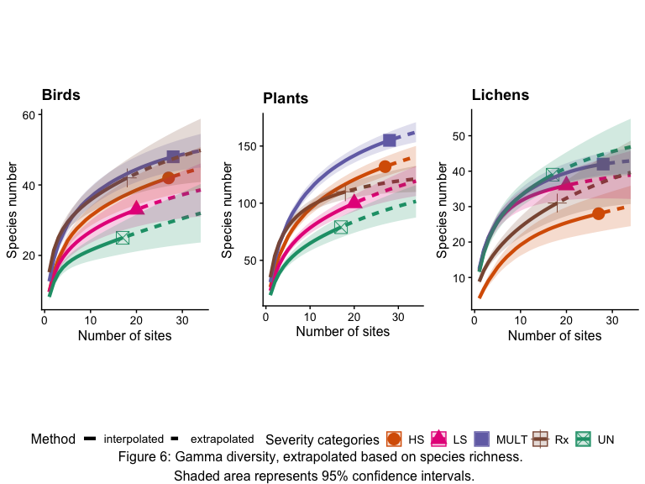

## Insect Indicator Species Analysis

Six insect taxa (order or suborder) were indicators of the high-severity habitats (table 2). These were mainly pollinators (Aculeata (bees/stinging wasps), Brachyceran flies, Coleoptera) and herbivores (Homoptera, Heteroptera, Orthoptera), which probably reflects the higher abundance of flowers and broadleaf shrubs/trees in high-severity burns.

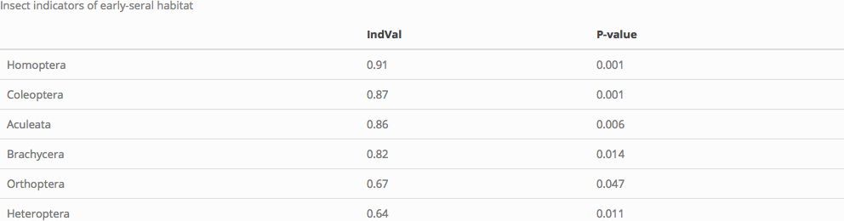

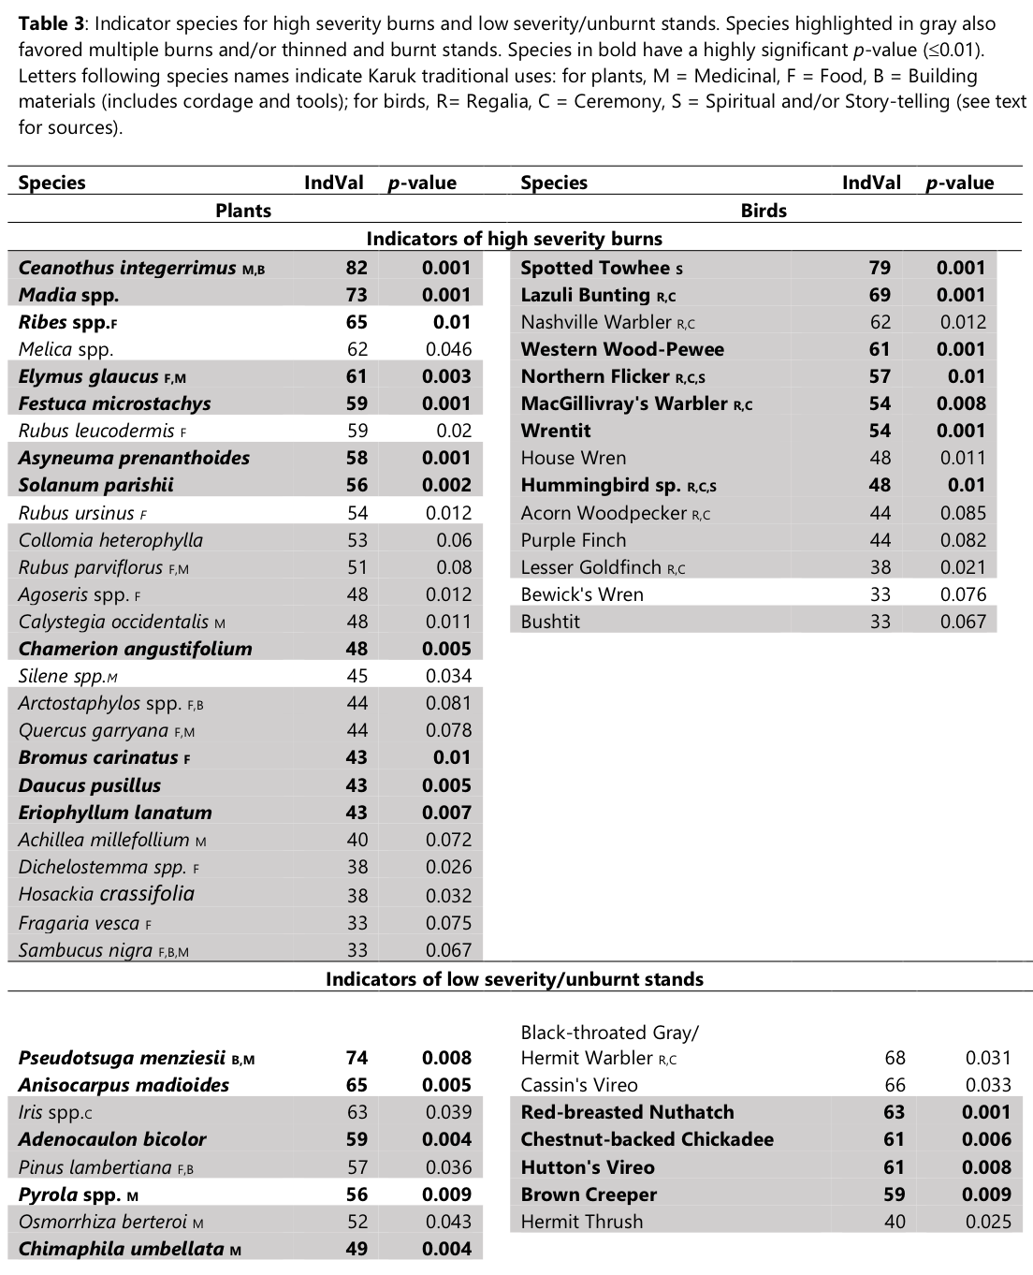

## Early and late seral species in actively and passively managed stands

The indicator analysis for birds and plants of high-severity and low-severity/unburnt stands suggests distinct communities in each habitat (Table 2). Plants preferring such stands were predictably shade-tolerant species (e.g. *Goodyera oblongifolia* (rattlesnake plantain), *Pyrola spp.* (wintergreen), *Adenocaulon bicolor* (pathfinder), *Anisocarpus madioides* (woodland tarweed)), whereas these stands were favored by bark-gleaning (Red-breasted Nuthatch and Brown Creeper) and canopy-dwelling birds (Chestnut-backed Chickadee, Black-throated Gray/Hermit Warbler, Cassin’s Vireo). In contrast, species that preferred early-seral conditions created by high-severity fire included shrubs (e.g. *Ceanothus integerrimus* (deerbrush), *Rubus spp.* (blackberries, raspberries and thimbleberries), *Arctostaphylos spp.* (manzanita), *Solanum parishii* (Parish’s nightshade)), grasses (e.g. *Melica spp.* (oniongrass), *Elymus glaucus* (blue wildrye), *Bromus carinatus* (California brome)), annual forbs (e.g. *Madia spp.* (tarweeds), *Collomia heterophylla* (vari-leaved collomia), *Cryptantha spp.* (popcorn flower), *Epilobium spp.* (willowherbs)) and perennial forbs (e.g. *Asyneuma prenanthoides* (California harebell), *Eriophyllum lanatum* (woolly sunflower), *Dichelostemma spp.* (blue dicks/Indian potatoes), *Chamerion angustifolium* (fireweed), *Hosackia crassifolia* (big deervetch)). Birds that favored these stands tended to be species associated with shrubs and deciduous tree cover (e.g. Spotted Towhee, Wrentit, Nashville Warbler, MacGillivray’s Warbler, Anna’s/Rufous Hummingbirds, Black-headed Grosbeak), open habitat species (Lesser Goldfinch, Lazuli Bunting), and cavity nesters (Acorn Woodpeckers, House Wren, Northern Flicker). This classification into early and late seral species agrees with other regional studies for those species for which information is available (Donato et al., 2009; Fontaine et al., 2009).

I identified 61 species (birds, plants and lichens combined) that seemed to favor high-severity burns (occurring at least twice as frequently in that habitat compared to low-severity and unburnt stands), and 45 species that favored low-severity and unburnt stands (occurring at least twice as frequently in that habitat compared to high-severity burns). These habitat associations correspond to the findings of other fire ecology studies (Fontaine et al., 2009). Additionally, most species that have a preference for either of these habitats exhibited the same affinity for multiple burns and thinned and burnt sites: 34 species (76%) preferring low-severity and unburnt stands also favor multiple burns, while 31 (69%) also favor thinned and burnt sites. Conversely, 49 species (80%) that prefer high-severity burns also favor multiple burns, and 41 (67%) also favor thinned and burnt sites. Figure 7 (a and b) displays graphically the proportion of plants and birds that prefer high-severity burns or unburnt and low-severity stands that also favor multiple burns and thin+burn sites.

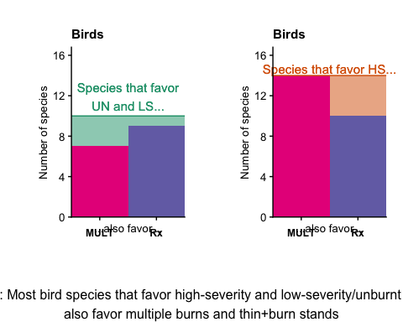

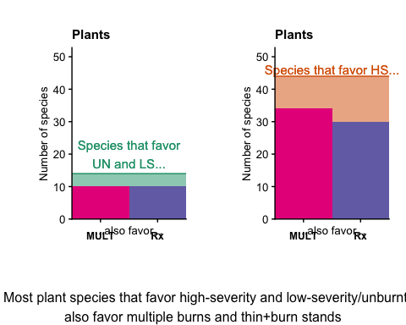

# Discussion

This study found that management options that mitigate the risk of high-severity fires by reducing canopy cover and continuity were also favorable to enhanced biodiversity outcomes for birds, plants, and lichens. Diversity for all three taxa was as high or higher in multiple burns and thin+burn plots than in either the high severity burns or the dense, long-unburnt or low-severity burn stands because the intermediate conditions provided habitat for both early and late seral species. Low-severity burns were not linked to a detectable change in species composition compared with long-unburnt stands. These stands had similar to lower diversity in birds, plants, lichens and insects compared with high-severity burn patches. Management that aims to mitigate the risk of high-severity fire by reducing canopy cover to 30-60% can also meet biodiversity objectives by accommodating both early and late seral associated species.

This finding is encouraging given the focus on increasing the pace and scale of forest restoration across the West (Charnley et al., 2016; Hessburg et al., 2015; North et al., 2012). Recent policy priorities have emphasized the expansion of forest restoration, while collaborative landscape restoration partnerships such as the WKRP have been building grassroots momentum and multi-stakeholder consensus for such projects (Harling and Tripp, 2014; Lake et al., 2018). In addition to the goal of reducing the risk of high-severity fires, such treatments aim to address the threat to biodiversity from fire suppression, which has reduced successional diversity and areas of open forest. These were once much more widespread due to historically frequent, low-severity fires, particularly in areas with a high level of ignitions from Native Americans (Crawford et al., 2015; Lake, 2013; Metlen et al., 2018; Taylor et al., 2016). Restoring a more open forest structure is expected to increase diversity in understory plants (Wayman and North, 2007; Webster and Halpern, 2010) and birds (Alexander et al., 2017; Gaines et al., 2010, 2007; Kalies and Rosenstock, 2013). Many studies have documented an increase in diversity at intermediate disturbance and canopy levels (Richter et al., 2019), although it is unclear whether this tends to benefit early-seral or late-seral associated species. Stevens et al. (2015) found that intermediate disturbance levels favored the coexistence of species with a northern (temperate) and southern (xeric) biogeographical affinities, while only the latter persisted after high severity burns. In contrast, some researchers have noted the benefits of high-severity fire for many species and suggested that forest restoration could damage habitat used by late-seral associates while creating conditions that are unsuitable for species associated with post-fire early-seral habitats (Odion et al., 2014, 2010). This study demonstrates that actively or passively restored stands are more diverse precisely because they accommodate both species associated with denser forests, and those associated with high-severity patches.

Despite a trend of increasing fire size, fire frequency remains significantly below historic levels across much of the landscape in the Klamath Mountains (Fry and Stephens, 2006; Miller et al., 2012; Steel et al., 2015; Taylor and Skinner, 1998). In other ecoregions with predominantly low- to moderate-severity fires, fire suppression has caused increases in canopy cover. Mixed conifer forests of the Sierra Nevada historically had a canopy cover of 17-50% (Safford and Stevens, 2017; S. L. Stephens et al., 2015). While precise estimates of historical canopy cover are lacking for the Klamath Mountains, it is clear that open forests and other vegetation types dependent on frequent fires have been lost across the region due to fire suppression, leading to a more homogenous, denser forest (Odion et al., 2010; Skinner, 1995; Skinner et al., 2006; Taylor and Skinner, 2003).

In this study, stands where fire had been excluded had the lowest plant species richness and the smallest pool of species for both birds and plants. Only select groups of species appear to prefer these conditions, including shade-tolerant plants and bark-gleaning and canopy-dwelling bird species. Fire-sensitive species, including all lichens and a small number of plants (eg. *Goodyera oblongifolia*) were also associated with these stands and absent from high-severity burns (lichens began to recolonize as early as 16 years after a high-severity burn). Meanwhile, the latter were home to a variety of shade-intolerant grasses, shrubs and forbs, and open area, shrub-nesting and cavity-nesting bird species that were found rarely, if ever, in unburnt stands. Several taxa of insect pollinators and herbivores were also strongly associated with high-severity burns. Arthropods are an important part of the diet of many bird species, and their increase after fires may favor insectivorous birds (Seavy and Alexander, 2014). Early-seral habitats created by fire are recognized for their importance to many taxa, including rare species (Swanson et al., 2014). Most plant and many bird species found in mature stands persisted in high-severity burn patches, a finding consistent with other studies in the region (Donato et al., 2009). While the species of denser, fire-suppressed stands and those of post-fire early seral habitats are largely segregated in today’s forested landscape, this pattern may not be representative of historical conditions in which finer-scale heterogeneity was prevalent (Hanberry et al., 2020; Skinner et al., 2006; Taylor and Skinner, 2003). However, few studies have clarified whether reductions in canopy cover following lower severity burns, multiple burns or thin+burn treatments can allow for these two groups of species to coexist within stands.

However, the sharp distinction between the species communities of denser forests and high-severity patches was not significantly altered by the occurrence of low-severity fire. While it might have been expected that surface fires would play a restorative role in fire-suppressed stands (leading to an increase in shade-intolerant species for example), the small magnitude of the reduction in canopy cover after a single low-severity burn was insufficient to achieve this result. Other studies in mixed conifer forest have suggested that a considerable reduction in canopy cover (to 30-50%) is necessary before understory richness can be expected to increase (Abella and Springer, 2015), with similar canopy cover levels suggested to maximize bird diversity (White et al., 2013). Douglas-firs (and white firs at higher elevations) are unlikely to be thinned by surface fires, particularly once they have reached 30cm dbh (Becker and Lutz, 2016; Collins et al., 2011; Knapp et al., 2013). Trees that have established since the criminalization of Indigenous burning (mid-1800s) and later the establishment of the policy of fire-suppression (around 1910) have reached this fire-resistant size in the productive forests of the Klamath Mountains. Further research is needed to evaluate the potential for multiple low-severity fires to reduce the density of these post-fire suppression trees. Low-severity fires prior to fire suppression were likely sufficient to maintain forest openings and early seral vegetation (Skinner, 1995), but in today’s fire suppressed stands, a greater level of tree mortality will likely be needed to restore a more open, patchy forest structure critical to the maintenance of biodiversity. Since low-severity fires are not significantly changing forest structure and species composition, management options that restore a lower canopy cover need to be considered.

The multiple burns and thin+burn stands in this study had a canopy cover of 30-75% (mean = 48%, sd = 15%), and were associated with the highest levels of species richness for birds and plants. Lichen species richness was also similar to that of the low-severity and unburnt stands. I also found that canopy cover was negatively associated with bird and plant species richness within these habitats. Canopy cover is recognized as a key driver of species diversity (Stephens et al., 2007; Stevens et al., 2019), and my findings echo the suggestion by Abella and Springer that a reduction in canopy cover to 30-50% is needed to achieve significant increases in species diversity (Abella and Springer, 2015). When management results in this level of canopy cover, species typically restricted to high-severity burns and those that occur in denser mature forests can coexist in a single stand.

Managing wildfires to achieve resource objectives is a strategy that is recommended for its outcomes for bird diversity (Fontaine et al., 2009; J. L. Stephens et al., 2015), plant diversity (Laughlin et al., 2004), and ecosystem resilience (Barros et al., 2018; Boisramé et al., 2017; Estes et al., 2017; Nesmith et al., 2011). While there has been a focus on the capacity of high-severity reburns to perpetuate “non-forest” vegetation conditions (Odion et al., 2010; Tepley et al., 2017; Thompson and Spies, 2010), multiple low- to moderate-severity burns can also increase fine-scale heterogeneity by creating multi-layered, patchy stands with canopy cover levels intermediate between unburnt (and low-severity) stands and high-severity burns. By creating gaps in the canopy (particularly that of resprouting hardwoods), short interval reburns favor the coexistence of species associated with mature forests and early seral species (particularly annual and disturbance-associated species and species with a long-lasting seed bank) (Donato et al., 2009). My results similarly suggest that such areas represent biodiversity hotspots on the landscape because the structure of these stands accommodates both fire-sensitive species (e.g. shade-tolerant plants, canopy-dwelling birds and lichens) and fire-dependent species (eg. shade-intolerant herbaceous plants and shrub-nesting birds).

Thinned and burnt stands achieved the same result, particularly when there had been a significant reduction in canopy cover. As was the case for the multiple burns, I focused my sampling on stands with a canopy cover of 30-70%. This represents a important reduction in canopy cover and may not represent standard underburn operations, which may make little impact on stand structure and thus biodiversity (Seavy and Alexander, 2006). But this study joins others in highlighting the ecological benefits of higher severity burns, or at least treatments that include patches of high-severity (Fulé et al., 2004; Stephens et al., 2012). Just like low-severity burns in this study, treatments that maintain a high canopy cover are unlikely to stimulate a response of understory diversity. Despite the potential benefits of treating stands to reverse the effects of fire exclusion, such treatments remain very scarce in the study region. This led to some sacrifices in sampling rigor (eg. sites were more spatially clustered), and as a result caution is needed in interpreting some of the results (eg. lower beta diversity in the thin+burn stands). More importantly, while the results are encouraging, the realtively small footprint of active forest restoration brings into question the ability for agencies and landscape collaboratives to deploy such treatments on the scale that is needed. Only 20% of the area in need of restoration annually is receiving treatment, and this will need to be re-treated every 15-30 years (North et al., 2012). Much more widespread restoration efforts will be needed, for example through collaborative approaches such as the WKRP. Wildland fire use should also be embraced to expand the scale of restoration, when weather and fuels conditions are appropriate, and consistent with the preservation of cultural and biological resources (North et al., 2012). In the meantime, unplanned ignitions -including small to moderately sized high-severity burn patches- can help maintain biodiversity by providing early successional habitat in the fire suppressed forests of the Klamath Mountains and across the West (Hutto et al., 2016).

This study had other weaknesses aside from the difficulty in finding acceptable actively restored stands. The number of samples and variation associated with complex topographic and environmental factors did not allow for an in-depth analysis of the role of time-since-fire, which may have masked the response of some species (Smucker et al., 2005). Scale-related challenges are common in ecological research, and this study was no exception, taking into account only stand-level variables but leaving out potentially important landscape patterns (Betts et al., 2010). Lastly, it would be useful to more thoroughly investigate the full range of outcomes from multiple burns and thin+burn treatments, including quantifying their spatial extent. This study joins others in showing that positive biodiversity outcomes are possible under some conditions, but to what extent these are realized remains to be determined. Despite these caveats, this study has clear and important management implications.

## Management implications

Fire suppressed stands have similar or lower plant and bird diversity (alpha, beta, gamma diversity) than high-severity burn burns, and a single low-severity burn does not appear to change this pattern. While high-severity burns are important for biodiversity when compared with unburnt/low-severity stands, species that are associated with both of these habitats also favor multiple burns and thinned and burnt stands. As a result, such stands are more diverse than either high-severity burns or unburnt/low-severity burn stands. This suggests that both active (thin+burn) and passive (wildland fire use) management can achieve biodiversity conservation goals while also achieving fuels reduction and forest and community resilience objectives.

Fuels reduction treatments can be conducted in a way that benefits biodiversity (Dodson and Peterson, 2010; Dodson et al., 2008; Stevens et al., 2015; Wayman and North, 2007). However, canopy cover and small to medium tree density must be significantly reduced to achieve such benefits (Abella and Springer, 2015; Kalies and Rosenstock, 2013), mechanical treatments should be followed by prescribed burning (Kane et al., 2010; Stevens et al., 2015; Wayman and North, 2007), and repeated treatments are necessary (Goodwin et al., 2018). This and other studies have found that such treatments are compatible with the conservation of many late seral and fire-sensitive species, including lichens (Miller et al., 2018). Multiple burns can achieve similar results, suggesting that wildland fire use should be increased to promote diverse forests at a larger scale than possible through active restoration treatments (North et al., 2012). In the absence of passive or active restoration, mosaics of different fire severities, including high-severity patches, are important to the maintenance of biodiversity in the fire suppressed forests of the Klamath Mountains.

Despite the benefits of forest thinning for biodiversity and risk reduction, managers face regulatory requirements to maintain closed canopy stands for the protection of listed late seral species, such as the Northern Spotted Owl/California Spotted Owl (*Strix occidentalis*). These policies can drive land managers towards a focus on late seral habitats, sometimes conflicting with the management of culturally important species (Long et al., 2015), and with multi-species conservation approaches (White et al., 2013). However, with proper spatial prioritization and thoughtful deliberation, reducing canopy cover to the level of the managed stands in this study may be compatible with Spotted Owl conservation (Lee and Irwin, 2005; Winford et al., 2015). In addiition, many late seral associates in forests with mixed severity fire regimes benefit from the complex intermixing of different seral stages (Hagar, 2007). Landscape-level planning that promotes a diversity of habitats rather than seeking to implement narrow prescriptions across large areas is most likely to achieve multi-species conservation goals, while conserving threatened late seral species (White et al., 2013).

Forest collaboratives often try to maximize additional objectives besides biodiversity conservation and fuels reduction. In the case of the WKRP, management for Indigenous cultural uses is an important priority. It is unclear whether the patterns in species richness and composition found in this study match the value of each habitat for the purposes of Indigenous cultural practitioners. Species of cultural importance were found in all habitats (table 2), but they may be of insufficient quality or quantity, or too difficult to access depending on the structure of the habitat. For example, the growth in recent high-severity burn patches is often too dense for elders to access cultural plants, whether they are present or not. Meanwhile, basketry plants growing in exposed conditions do not develop in a way that is optimal for the use of weavers (Hummel et al., 2015; Marks-Block et al., 2019). While this study found that biodiversity is maximized in stands with intermediate canopy cover, further research is needed to determine whether such stands also present high cultural value from the perspective of Karuk cultural practitioners. Alternative ignition patterns, pre- and post-treatment interventions, and adaptive management based on traditional ecological knowledge will likely be needed for optimal management of cultural species beyond their conservation value.

# Acknowledgements

I would like to extend my deepest gratitude to the Karuk Tribe and tribal members and fire practitioners including Frank Lake, Bill Tripp, Renée Stauffer, and members of the Karuk Research Approval Board for their guidance. I am also grateful to the staff of the USDA Forest Service Six Rivers and Klamath National Forests for their support, and to my academic mentors at UC Davis, including Beth Rose Middleton, Hugh Safford, and Dan Potter. Several brave interns helped me gather the data and process insect specimens: Jacob Wilson, Diana Cuevas, Shaden Cortez, Vincent Ho, and Sierra Schluep. Funding was provided by the Henry A. Jastro Research Fellowship, California Lichen Society, Northern California Botanists, and California Native Plant Society.

# References

Abella, S.R., Springer, J.D., 2015. Effects of tree cutting and fire on understory vegetation in mixed conifer forests. Forest Ecology and Management 335, 281–299. <https://doi.org/10.1016/j.foreco.2014.09.009>

Alexander, J.D., Stephens, J.L., Veloz, S., Salas, L., Rousseau, J.S., Ralph, C.J., Sarr, D.A., 2017. Using regional bird density distribution models to evaluate protected area networks and inform conservation planning. Ecosphere 8, n/a–n/a. <https://doi.org/10.1002/ecs2.1799>

Anderson, M.J., 2017. Permutational Multivariate Analysis of Variance (PERMANOVA), in: Wiley StatsRef: Statistics Reference Online. American Cancer Society, pp. 1–15. <https://doi.org/10.1002/9781118445112.stat07841>

Baker, W.L., 2015. Are High-Severity Fires Burning at Much Higher Rates Recently than Historically in Dry-Forest Landscapes of the Western USA? PLoS ONE 10. <https://doi.org/10.1371/journal.pone.0136147>

Baldwin, B.G., Goldman, D.H., Keil, D.J., Patterson, R., Rosatti, T.J., Vorobik, L.A., 2012. The Jepson manual: Vascular plants of California. Univ of California Press.

Barbour, M.G., Billings, W.D., 2000. North American terrestrial vegetation. Cambridge University Press.

Barros, A.M.G., Alan A., A., Day, M.A., Krawchuk, M.A., Spies, T.A., 2018. Wildfires managed for restoration enhance ecological resilience. Ecosphere 9, e02161. <https://doi.org/10.1002/ecs2.2161>

Bartuszevige, A.M., Kennedy, P.L., 2009. Synthesis of knowledge on the effects of fire and thinning treatments on understory vegetation in US dry forests.

Becker, K.M., Lutz, J.A., 2016. Can low-severity fire reverse compositional change in montane forests of the Sierra Nevada, California, USA? Ecosphere 7.

Betts, M.G., Hagar, J.C., Rivers, J.W., Alexander, J.D., McGarigal, K., McComb, B.C., 2010. Thresholds in forest bird occurrence as a function of the amount of early-seral broadleaf forest at landscape scales. Ecological Applications 20, 2116–2130.

Boisramé, G.F.S., Thompson, S.E., Kelly, M., Cavalli, J., Wilkin, K.M., Stephens, S.L., 2017. Vegetation change during 40years of repeated managed wildfires in the Sierra Nevada, California. Forest Ecology and Management 402, 241–252. <https://doi.org/10.1016/j.foreco.2017.07.034>

Carloni, K.R., 2005. The ecological legacy of Indian burning practices in southwestern Oregon (PhD Thesis). Oregon State University.

Chao, A., Gotelli, N.J., Hsieh, T.C., Sander, E.L., Ma, K.H., Colwell, R.K., Ellison, A.M., 2014. Rarefaction and extrapolation with Hill numbers: A framework for sampling and estimation in species diversity studies. Ecological Monographs 84, 45–67. <https://doi.org/10.1890/13-0133.1>

Charnley, S., Kelly, E.C., Wendel, K.L., 2016. All lands approaches to fire management in the Pacific West: A typology. Journal of Forestry 115, 16–25.

Collins, B.M., Everett, R.G., Stephens, S.L.;., 2011. Impacts of fire exclusion and recent managed fire on forest structure in old growth Sierra Nevada mixed-conifer forests. Ecosphere 2, 1–14.

Colwell, R.K., Chao, A., Gotelli, N.J., Lin, S.-Y., Mao, C.X., Chazdon, R.L., Longino, J.T., 2012. Models and estimators linking individual-based and sample-based rarefaction, extrapolation and comparison of assemblages. Journal of Plant Ecology 5, 3–21. <https://doi.org/10.1093/jpe/rtr044>

Crawford, J.N., Mensing, S.A., Lake, F.K., Zimmerman, S.R., 2015. Late Holocene fire and vegetation reconstruction from the western Klamath Mountains, California, USA: A multi-disciplinary approach for examining potential human land-use impacts. The Holocene 25, 1341–1357. <https://doi.org/10.1177/0959683615584205>

De Cáceres, M., Legendre, P., 2009. Associations between species and groups of sites: Indices and statistical inference. Ecology 90, 3566–3574.

Dodson, E.K., Peterson, D.W., 2010. Dry coniferous forest restoration and understory plant diversity: The importance of community heterogeneity and the scale of observation. Forest Ecology and Management 260, 1702–1707. <https://doi.org/10.1016/j.foreco.2010.08.012>

Dodson, E.K., Peterson, D.W., Harrod, R.J., 2008. Understory vegetation response to thinning and burning restoration treatments in dry conifer forests of the eastern Cascades, USA. Forest Ecology and Management. 255: 3130-3140.

Donato, D.C., Fontaine, J.B., Robinson, W.D., Kauffman, J.B., Law, B.E., 2009. Vegetation response to a short interval between high-severity wildfires in a mixed-evergreen forest. Journal of Ecology 97, 142–154. <https://doi.org/10.1111/j.1365-2745.2008.01456.x>

Estes, B.L., Knapp, E.E., Skinner, C.N., Miller, J.D., Preisler, H.K., 2017. Factors influencing fire severity under moderate burning conditions in the Klamath Mountains, northern California, USA. Ecosphere 8, n/a–n/a. <https://doi.org/10.1002/ecs2.1794>

Flint, L.E., Flint, A.L., Thorne, J.H., Boynton, R., 2013. Fine-scale hydrologic modeling for regional landscape applications: The California Basin Characterization Model development and performance. Ecological Processes 2, 25. <https://doi.org/10.1186/2192-1709-2-25>

Fontaine, J.B., Donato, D.C., Robinson, W.D., Law, B.E., Kauffman, J.B., 2009. Bird communities following high-severity fire: Response to single and repeat fires in a mixed-evergreen forest, Oregon, USA. Forest Ecology and Management 257, 1496–1504. <https://doi.org/10.1016/j.foreco.2008.12.030>

Fry, D.L., Stephens, S.L., 2006. Influence of humans and climate on the fire history of a ponderosa pine-mixed conifer forest in the southeastern Klamath Mountains, California. Forest Ecology and Management 223, 428–438. <https://doi.org/10.1016/j.foreco.2005.12.021>

Fulé, P.Z., Cocke, A.E., Heinlein, T.A., Covington, W.W., 2004. Effects of an Intense Prescribed Forest Fire: Is It Ecological Restoration? Restoration Ecology 12, 220–230. <https://doi.org/10.1111/j.1061-2971.2004.00283.x>

Gaines, W., Haggard, M., Begley, J., Lehmkuhl, J., Lyons, A., 2010. Short-Term Effects of Thinning and Burning Restoration Treatments on Avian Community Composition, Density, and Nest Survival in the Eastern Cascades Dry Forests, Washington. Forest Science 56, 88–99. <https://doi.org/10.1093/forestscience/56.1.88>

Gaines, W.L., Haggard, M., Lehmkuhl, J.F., Lyons, A.L., Harrod, R.J., 2007. Short-Term Response of Land Birds to Ponderosa Pine Restoration. Restoration Ecology 15, 670–678. <https://doi.org/10.1111/j.1526-100X.2007.00279.x>

Goodwin, M.J., North, M.P., Zald, H.S.J., Hurteau, M.D., 2018. The 15-year post-treatment response of a mixed-conifer understory plant community to thinning and burning treatments. Forest Ecology and Management 429, 617–624. <https://doi.org/10.1016/j.foreco.2018.07.058>

Hagar, J.C., 2007. Wildlife species associated with non-coniferous vegetation in Pacific Northwest conifer forests: A review. Forest Ecology and Management, Biodiversity Management in Pacific Northwest Forests: Strategies and Opportunities. 246, 108–122. <https://doi.org/10.1016/j.foreco.2007.03.054>

Halofsky, J.E., Donato, D.C., Hibbs, D.E., Campbell, J.L., Cannon, M.D., Fontaine, J.B., Thompson, J.R., Anthony, R.G., Bormann, B.T., Kayes, L.J., Law, B.E., Peterson, D.L., Spies, T.A., 2011. Mixed-severity fire regimes: Lessons and hypotheses from the Klamath-Siskiyou Ecoregion. Ecosphere 2, 1–19. <https://doi.org/10.1890/ES10-00184.1>

Hanberry, B.B., Bragg, D.C., Alexander, H.D., 2020. Open forest ecosystems: An excluded state. Forest Ecology and Management 472, 118256. <https://doi.org/10.1016/j.foreco.2020.118256>

Harling, W., Tripp, B., 2014. Western Klamath Restoration Partnership: A Plan for Restoring Fire Adapted Landscapes.

Haugo, R.D., Kellogg, B.S., Cansler, C.A., Kolden, C.A., Kemp, K.B., Robertson, J.C., Metlen, K.L., Vaillant, N.M., Restaino, C.M., 2019. The missing fire: Quantifying human exclusion of wildfire in Pacific Northwest forests, USA. Ecosphere 10, e02702. <https://doi.org/10.1002/ecs2.2702>

Hessburg, P.F., Agee, J.K., Franklin, J.F., 2005. Dry forests and wildland fires of the inland Northwest USA: Contrasting the landscape ecology of the pre-settlement and modern eras. Forest Ecology and Management, Relative Risk Assessments for Decision Making Related To Uncharacteristic Wildfire 211, 117–139. <https://doi.org/10.1016/j.foreco.2005.02.016>

Hessburg, P.F., Churchill, D.J., Larson, A.J., Haugo, R.D., Miller, C., Spies, T.A., North, M.P., Povak, N.A., Belote, R.T., Singleton, P.H., Gaines, W.L., Keane, R.E., Aplet, G.H., Stephens, S.L., Morgan, P., Bisson, P.A., Rieman, B.E., Salter, R.B., Reeves, G.H., 2015. Restoring fire-prone Inland Pacific landscapes: Seven core principles. Landscape Ecology 30, 1805–1835. <https://doi.org/10.1007/s10980-015-0218-0>

Hessburg, P.F., Spies, T.A., Perry, D.A., Skinner, C.N., Taylor, A.H., Brown, P.M., Stephens, S.L., Larson, A.J., Churchill, D.J., Povak, N.A., 2016. Tamm review: Management of mixed-severity fire regime forests in Oregon, Washington, and Northern California. Forest Ecology and Management 366, 221–250.

Hsieh, T.C., Ma, K.H., Chao, A., 2016. iNEXT: An R package for rarefaction and extrapolation of species diversity (Hill numbers). Methods in Ecology and Evolution 7, 1451–1456. <https://doi.org/10.1111/2041-210X.12613>

Hummel, S., Lake, F., Watts, A.;., 2015. Using forest knowledge: How silviculture can benefit from ecological knowledge systems about beargrass harvesting sites.

Hutto, R.L., Keane, R.E., Sherriff, R.L., Rota, C.T., Eby, L.A., Saab, V.A., 2016. Toward a more ecologically informed view of severe forest fires. Ecosphere 7, n/a–n/a. <https://doi.org/10.1002/ecs2.1255>

Jost, L., 2007. Partitioning Diversity into Independent Alpha and Beta Components. Ecology 88, 2427–2439. <https://doi.org/10.1890/06-1736.1>

Kalies, E.L., Rosenstock, S.S., 2013. Stand structure and breeding birds: Implications for restoring ponderosa pine forests. The Journal of Wildlife Management 77, 1157–1165. <https://doi.org/10.1002/jwmg.577>

Kalies, E.L., Yocom Kent, L.L., 2016. Tamm Review: Are fuel treatments effective at achieving ecological and social objectives? A systematic review. Forest Ecology and Management 375, 84–95. <https://doi.org/10.1016/j.foreco.2016.05.021>

Kane, J.M., Varner, J.M., Knapp, E.E., Powers, R.F., 2010. Understory vegetation response to mechanical mastication and other fuels treatments in a ponderosa pine forest. Applied Vegetation Science 13, 207–220. <https://doi.org/10.1111/j.1654-109X.2009.01062.x>

Knapp, E.E., Skinner, C.N., North, M.P., Estes, B.L., 2013. Long-term overstory and understory change following logging and fire exclusion in a Sierra Nevada mixed-conifer forest. Forest Ecology and Management 310, 903–914. <https://doi.org/10.1016/j.foreco.2013.09.041>

Lake, F.K.;., 2013. Historical and cultural fires, tribal management and research issue in Northern California: Trails, fires and tribulations.

Lake, F., Parrotta, J., Giardina, C., Hunt-Davidson, I., Uprety, Y., 2018. Integration of Traditional and Western knowledge in forest landscape restoration. Forest Landscape Restoration: Integrated approaches to support effective implementation 198–226.

Laughlin, D.C., Bakker, J.D., Stoddard, M.T., Daniels, M.L., Springer, J.D., Gildar, C.N., Green, A.M., Covington, W.W., 2004. Toward reference conditions: Wildfire effects on flora in an old-growth ponderosa pine forest. Forest Ecology and Management 199, 137–152. <https://doi.org/10.1016/j.foreco.2004.05.034>

Lee, D.C., Irwin, L.L., 2005. Assessing risks to spotted owls from forest thinning in fire-adapted forests of the western United States. Forest Ecology and Management, Relative Risk Assessments for Decision Making Related To Uncharacteristic WildfireRelative Risk Assessments for Decision Making Related To Uncharacteristic Wildfire 211, 191–209. <https://doi.org/10.1016/j.foreco.2005.02.001>

Long, J.W., Lake, F.K., Alexander, J.D., Wolfe, J.D., 2020. Using culturally significant birds to guide the timing of prescribed burns in the Klamath-Siskiyou bioregion. Forest Ecology and Management.

Long, J.W., Quinn-Davidson, L., Goode, R.W., Lake, F.K., Skinner, C.N.;., 2015. Restoring California black oak to support tribal values and wildlife.

Marks-Block, T., Lake, F.K., Curran, L.M., 2019. Effects of understory fire management treatments on California Hazelnut, an ecocultural resource of the Karuk and Yurok Indians in the Pacific Northwest. Forest Ecology and Management 450, 117517. <https://doi.org/10.1016/j.foreco.2019.117517>

McArdle, B.H., Anderson, M.J., 2001. Fitting multivariate models to community data: A comment on distance-based redundancy analysis. Ecology 82, 290–297.

McCune, B., Geiser, L., 2009. Macrolichens of the Pacific Northwest, 2nd edition. ed. Oregon State University Press.

McCune, B., Keon, D., 2002. Equations for potential annual direct incident radiation and heat load. Journal of Vegetation Science 13, 603–606. <https://doi.org/10.1111/j.1654-1103.2002.tb02087.x>

Metlen, K.L., Skinner, C.N., Olson, D.R., Nichols, C., Borgias, D., 2018. Regional and local controls on historical fire regimes of dry forests and woodlands in the Rogue River Basin, Oregon, USA. Forest Ecology and Management 430, 43–58. <https://doi.org/10.1016/j.foreco.2018.07.010>

Miller, J.D., Knapp, E.E., Key, C.H., Skinner, C.N., Isbell, C.J., Creasy, R.M., Sherlock, J.W., 2009. Calibration and validation of the relative differenced Normalized Burn Ratio (RdNBR) to three measures of fire severity in the Sierra Nevada and Klamath Mountains, California, USA. Remote Sensing of Environment, 113(3): 645-656 113, 645–656. <https://doi.org/10.1016/j.rse.2008.11.009>

Miller, J.D., Safford, H.D., Crimmins, M., Thode, A.E., 2009. Quantitative Evidence for Increasing Forest Fire Severity in the Sierra Nevada and Southern Cascade Mountains, California and Nevada, USA. Ecosystems 12, 16–32. <https://doi.org/10.1007/s10021-008-9201-9>

Miller, J.D., Skinner, C.N., Safford, H.D., Knapp, E.E., Ramirez, C.M., 2012. Trends and causes of severity, size, and number of fires in northwestern California, USA. Ecological Applications 22, 184–203. <https://doi.org/10.1890/10-2108.1>

Miller, J.D., Thode, A.E., 2007. Quantifying burn severity in a heterogeneous landscape with a relative version of the delta Normalized Burn Ratio (dNBR). Remote Sensing of Environment 109, 66–80. <https://doi.org/10.1016/j.rse.2006.12.006>

Miller, J.E.D., Root, H.T., Safford, H.D., 2018. Altered fire regimes cause long-term lichen diversity losses. Global Change Biology 1–10. <https://doi.org/10.1111/gcb.14393>

Miller, J.E.D., Safford, H., 2019. Plant community responses to wildfire may be contingent upon historical disturbance regimes. <https://doi.org/10.32942/osf.io/8sxfh>

Moghaddas, J.J., Collins, B.M., Menning, K., Moghaddas, E.E., Stephens, S.L., 2010. Fuel treatment effects on modeled landscape-level fire behavior in the northern Sierra Nevada. Canadian Journal of Forest Research 40, 1751–1765.

Nesmith, J.C., Caprio, A.C., Pfaff, A.H., McGinnis, T.W., Keeley, J.E., 2011. A comparison of effects from prescribed fires and wildfires managed for resource objectives in Sequoia and Kings Canyon National Parks. Forest Ecology and Management 261, 1275–1282.

North, M., Collins, B.M., Stephens, S., 2012. Using Fire to Increase the Scale, Benefits, and Future Maintenance of Fuels Treatments. Journal of Forestry 110, 392–401. <https://doi.org/10.5849/jof.12-021>

Odion, D.C., Hanson, C.T., Arsenault, A., Baker, W.L., DellaSala, D.A., Hutto, R.L., Klenner, W., Moritz, M.A., Sherriff, R.L., Veblen, T.T., Williams, M.A., 2014. Examining Historical and Current Mixed-Severity Fire Regimes in Ponderosa Pine and Mixed-Conifer Forests of Western North America. PLOS ONE 9, e87852. <https://doi.org/10.1371/journal.pone.0087852>

Odion, D.C., Moritz, M.A., DellaSala, D.A., 2010. Alternative community states maintained by fire in the Klamath Mountains, USA. Journal of Ecology 98, 96–105. <https://doi.org/10.1111/j.1365-2745.2009.01597.x>

Oksanen, J., Kindt, R., Legendre, P., O’Hara, B., Stevens, M.H.H., Oksanen, M.J., Suggests, M., 2007. The vegan package. Community ecology package 10, 631–637.

Perry, D.A., Hessburg, P.F., Skinner, C.N., Spies, T.A., Stephens, S.L., Taylor, A.H., Franklin, J.F., McComb, B., Riegel, G., 2011. The ecology of mixed severity fire regimes in Washington, Oregon, and Northern California. Forest Ecology and Management 262, 703–717.

Ralph, C.J., Geupel, G.R., Pyle, P., Martin, T.E., DeSante, D.F., 1993. Handbook of field methods for monitoring landbirds. USDA Forest Service/UNL Faculty Publications 105.

Rice, W.R., 1989. Analyzing tables of statistical tests. Evolution 43, 223–225.

Richter, C., Rejmánek, M., Miller, J.E.D., Welch, K.R., Weeks, J., Safford, H., 2019. The species diversity x fire severity relationship is hump-shaped in semiarid yellow pine and mixed conifer forests. Ecosphere 10, e02882. <https://doi.org/10.1002/ecs2.2882>

Russo, L., Stehouwer, R., Heberling, J.M., Shea, K., 2011. The Composite Insect Trap: An Innovative Combination Trap for Biologically Diverse Sampling. PLOS ONE 6, e21079. <https://doi.org/10.1371/journal.pone.0021079>

Safford, H.D., Stevens, J.T., 2017. Natural range of variation for yellow pine and mixed-conifer forests in the Sierra Nevada, southern Cascades, and Modoc and Inyo National Forests, California, USA. Gen. Tech. Rep. PSW-GTR-256. Albany, CA: U.S. Department of Agriculture, Forest Service, Pacific Southwest Research Station. 229 p. 256.

Safford, H.D., Van de Water, K., Schmidt, D., 2011. California Fire Return Interval Departure (FRID) map metadata: Description of purpose, data sources, database fields, and their calculations. USDA Forest Service, Pacific Southwest Region, Vallejo.

Schenck, S.M., Gifford, E.W., 1952. Karok Ethnobotany. University of California Press.

Seavy, N.E., Alexander, J.D., 2014. Songbird response to wildfire in mixed-conifer forest in south-western Oregon. International Journal of Wildland Fire 23, 246–258. <https://doi.org/10.1071/WF12081>

Seavy, N.E., Alexander, J.D., 2006. Measuring ecological effects of prescribed fire using birds as indicators of forest conditions.

Skinner, C.N., 1995. Change in spatial characteristics of forest openings in the Klamath Mountains of northwestern California, USA. Landscape Ecology 10, 219–228. <https://doi.org/10.1007/BF00129256>

Skinner, C.N., Abbott, C.S., Fry, D.L., Stephens, S.L., Taylor, A.H., Trouet, V., 2009. Human and Climatic Influences on Fire Occurrence in California’s North Coast Range, USA. Fire Ecology 5, 76–99. <https://doi.org/10.4996/fireecology.0503076>

Skinner, C.N., Taylor, A.H., Agee, J.K., 2006. Klamath Mountains bioregion. In: N. G. Sugihara, J. W. van Wagtendonk, J. Fites-Kaufmann, K. E. Shaffer, and A. E. Thode, editors. 2006. Fire in California’s ecosystems. University of California Press, Berkeley. pp. 170-194 170–194.

Smucker, K.M., Hutto, R.L., Steele, B.M., 2005. Changes in bird abundance after wildfire: Importance of fire severity and time since fire. Ecological Applications 15, 1535–1549.

Steel, Z.L., Safford, H.D., Viers, J.H., 2015. The fire frequency-severity relationship and the legacy of fire suppression in California forests. Ecosphere 6, art8. <https://doi.org/10.1890/ES14-00224.1>

Stephens, J.L., Ausprey, I.J., Seavy, N.E., Alexander, J.D., 2015. Fire severity affects mixed broadleafConifer forest bird communities: Results for 9 years following fire. The Condor 117, 430–446. <https://doi.org/10.1650/CONDOR-14-58.1>

Stephens, S.L., Fry, D.L., Franco-Vizcaíno, E., Collins, B.M., Moghaddas, J.M., 2007. Coarse woody debris and canopy cover in an old-growth Jeffrey pine-mixed conifer forest from the Sierra San Pedro Martir, Mexico. Forest Ecology and Management 240, 87–95. <https://doi.org/10.1016/j.foreco.2006.12.012>

Stephens, S.L., Lydersen, J.M., Collins, B.M., Fry, D.L., Meyer, M.D., 2015. Historical and current landscape-scale ponderosa pine and mixed conifer forest structure in the Southern Sierra Nevada. Ecosphere 6, 1–63. <https://doi.org/10.1890/ES14-00379.1>

Stephens, S.L., McIver, J.D., Boerner, R.E.J., Fettig, C.J., Fontaine, J.B., Hartsough, B.R., Kennedy, P.L., Schwilk, D.W., 2012. The Effects of Forest Fuel-Reduction Treatments in the United States. BioScience 62, 549–560. <https://doi.org/10.1525/bio.2012.62.6.6>

Stevens, J.T., Miller, J.E.D., Fornwalt, P.J., 2019. Fire severity and changing composition of forest understory plant communities. Journal of Vegetation Science 30, 1099–1109. <https://doi.org/10.1111/jvs.12796>

Stevens, J.T., Safford, H.D., Harrison, S., Latimer, A.M., 2015. Forest disturbance accelerates thermophilization of understory plant communities. Journal of Ecology 103, 1253–1263. <https://doi.org/10.1111/1365-2745.12426>

Swanson, M.E., Studevant, N.M., Campbell, J.L., Donato, D.C., 2014. Biological associates of early-seral pre-forest in the Pacific Northwest. Forest ecology and management 324, 160–171.

Taylor, A.H., Skinner, C.N., 2003. Spatial patterns and controls on historical fire regimes and forest structure in the Klamath Mountains.

Taylor, A.H., Skinner, C.N., 1998. Fire history and landscape dynamics in a late-successional reserve, Klamath Mountains, California, USA. Forest Ecology and Management 111, 285–301. <https://doi.org/10.1016/S0378-1127(98)00342-9>

Taylor, A.H., Trouet, V., Skinner, C.N., Stephens, S., 2016. Socioecological transitions trigger fire regime shifts and modulate fire-climate interactions in the Sierra Nevada, USA, 16002015 CE. Proceedings of the National Academy of Sciences 201609775. <https://doi.org/10.1073/pnas.1609775113>

Tepley, A.J., Thompson, J.R., Epstein, H.E., Anderson-Teixeira, K.J., 2017. Vulnerability to forest loss through altered postfire recovery dynamics in a warming climate in the Klamath Mountains. Global Change Biology 23, 4117–4132. <https://doi.org/10.1111/gcb.13704>

Thompson, J.R., Spies, T.A., 2010. Factors associated with crown damage following recurring mixed-severity wildfires and post-fire management in southwestern Oregon. Landscape Ecology 25, 775–789. <https://doi.org/10.1007/s10980-010-9456-3>

USFS, 2008. Common stand exam user’s guide. USDA Forest Service, Albany, California, USA.

Van de Water, K.M., Safford, H.D., 2011. A Summary of Fire Frequency Estimates for California Vegetation before Euro-American Settlement. Fire Ecology 7, 26–58. <https://doi.org/10.4996/fireecology.0703026>

Wayman, R.B., North, M., 2007. Initial response of a mixed-conifer understory plant community to burning and thinning restoration treatments. Forest Ecology and Management 239, 32–44. <https://doi.org/10.1016/j.foreco.2006.11.011>

Webster, K.M., Halpern, C.B., 2010. Long-term vegetation responses to reintroduction and repeated use of fire in mixed-conifer forests of the Sierra Nevada. Ecosphere 1, 1–27. <https://doi.org/10.1890/ES10-00018.1>

Wheeler, B., Torchiano, M., 2016. lmPerm: Permutation tests for linear models. R Package Version 2.1.0.

White, A.M., Zipkin, E.F., Manley, P.N., Schlesinger, M.D., 2013. Conservation of Avian Diversity in the Sierra Nevada: Moving beyond a Single-Species Management Focus. PLOS ONE 8, e63088. <https://doi.org/10.1371/journal.pone.0063088>

Whittaker, R.H., 1961. VEGETATION HISTORY OF THE PACIFIC COAST STATES AND THE "CENTRAL" SIGNIFICANCE OF THE KLAMATH REGION. Madroño 16, 5–23.

Willms, J., Bartuszevige, A., Schwilk, D.W., Kennedy, P.L., 2017. The effects of thinning and burning on understory vegetation in North America: A meta-analysis. Forest Ecology and Management 392, 184–194. <https://doi.org/10.1016/j.foreco.2017.03.010>

Winford, E., Stevens, J., Safford, H., 2015. Effects of fuel treatments on California mixed-conifer forests. California Agriculture 69, 150–156.